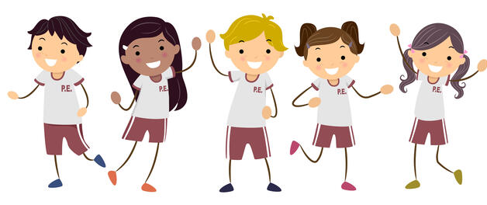


EYFS (Reception) – Monday (Hall)
Year 1 – Wednesday (Hall) and Friday (Outside)
Year 2 – Wednesday (Hall) and Thursday (Outside)
Year 3 – Wednesday (Outdoors) and Friday (Hall)
Year 4 – Tuesday (Hall) and Wednesday (Outside)
Year 5 – Tuesday (Outdoors) and Wednesday (Outdoors)
Year 6 – Monday (Outside) and Thursday (Hall)
PE Timetables – April – July 2026

