
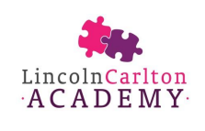

Reception Welcome Pack

Welcome to our School Family


I am delighted you have chosen Lincoln Carlton Academy as the place where your little one will start their Primary School journey. We are a large primary school of 436 children and over 70 staff but we pride ourselves on knowing each and every child along with their wider family. This is a particularly exciting year for me as I move into the role of Headteacher after 13 years of working at LCA as part of the senior leadership team.

I know from my own experience as a parent that the transition into school can bring a whole range of feelings – excitement, apprehension, sadness and everything in between. I am here to reassure you that all of these feelings are normal and OK! At this point, you will probably have a huge number of questions and I hope that this handbook will start to answer some of those for you. We are here to support you and your child so if you have any questions, please do get in contact and we will do our best to help.

Mrs Amy Melhuish
Deputy Headteacher

Meet the Staff
The Senior Leadership Team
Mrs Amy Melhuish will be the Headteacher. She is also the Deputy Designated Safeguarding Lead and has responsibility for the overall running of the school.


Mrs Sara Wright will be the Deputy Headteacher. She is the Deputy Designated Safeguarding Lead and has responsibility for curriculum development and maintaining standards in teaching and learning.


Mrs Ruth Clark is our Assistant Head and the Special Educational Needs Coordinator (SENDO). She is responsible for supporting children and their families where a need has been identified.


Mrs Natalie Goodacre is our Designated Safeguarding Lead and our Family Support Worker.

The UK School System

A primary school consists of three Key Stages.

The first Key Stage is the Early Years Foundation Stage (EYFS). The first year of school is called Reception. However, this actually marks the final year of your child’s birth to five curriculum journey (providing they have attended a child minder or nursery setting).

At the end of the Reception year, children will transition to Year 1 which marks the start of Key Stage One (KS1). Year 2 is also part of KS1. Year 1 is where children start to study the National Curriculum as laid out by the Government.

Key Stage Two (KS2) includes Year 3, 4, 5 and 6. A the end of KS2, all children will transition to a Secondary School.

The School Day
The school day starts promptly at 8:55am. The main gates to school will open at 8:45am so that you can be ready to leave your child on time.

The children eat lunch at 11:50am followed by playtime on the big playground until 1:00pm.

The school days ends promptly at 3:25pm and all children must be collected at this time.

How to find your child’s classroom
Here is a map showing the two walking routes to the Reception Class gate. This gate will open at 8:45am and close at 9am. There will always be a senior member of staff to show you where you need to go!

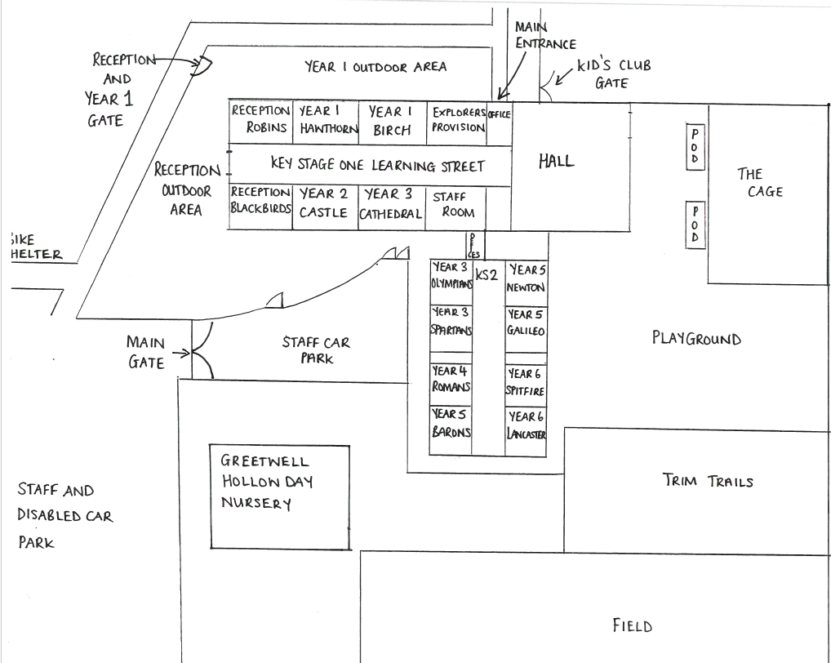

Dropping off and collecting your child
The school gates are unlocked at 8:45am with classroom doors opening at 8:55am for Reception children. The gates will close again at 9am so it is vital that your child is in school at this point. Otherwise, they will be considered late. There will always be a senior member of staff standing at the school gate and your child’s class teacher will be at the classroom door. Drop-off is very busy with all 60 children arriving at the same time. You might need to pass a message to your child’s teacher but you can also pass messages to one of the senior team who will pass it on.

At the end of the school day, the gates will open at 3:20pm with children being dismissed from the classroom doors at 3:25pm. Staff will only release children to the adults listed on their school record. If your child is going to be picked up by someone else, you must contact the school office prior to 3:00pm. If messages are not received then we are unable to release children.

One of the biggest differences between nursery settings and school is the availability of staff to speak to parents and carers at the end of the school day. You may be used to your child’s key worker giving you a daily update on your child but this is not possible with all 60 children leaving at once. Please rest assured that if your child’s class teacher has any concerns then they will make contact with you.

Uniform Policy
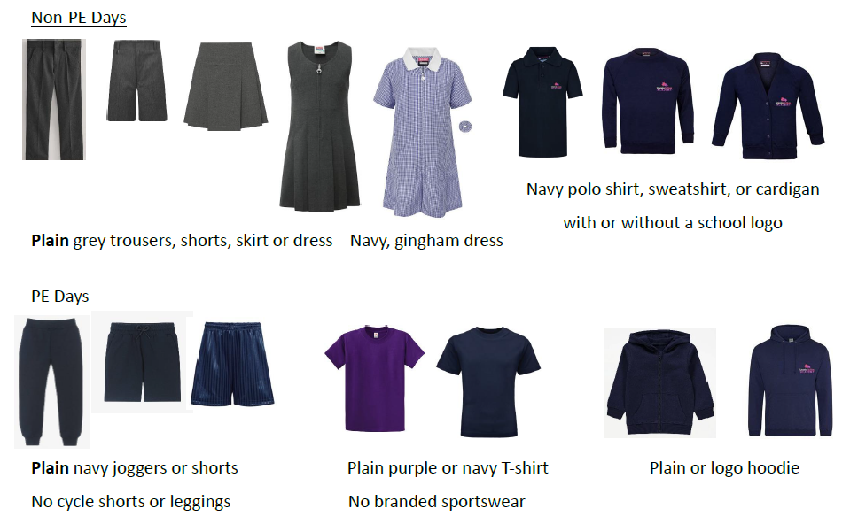

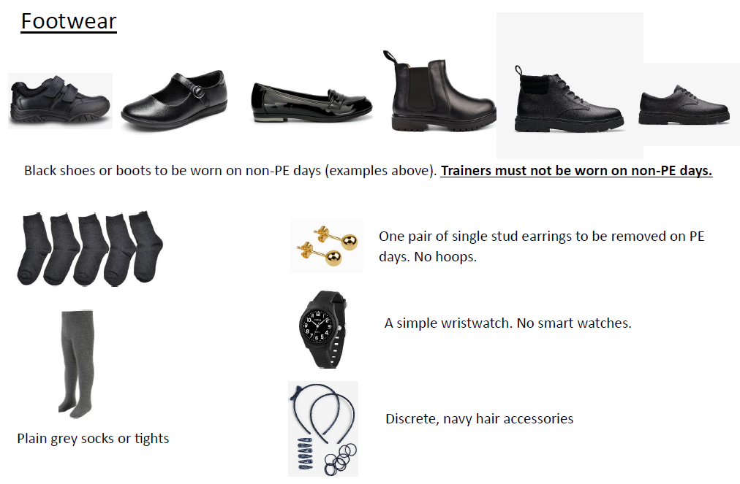

The Early Years Foundation Stage Curriculum
The Early Years Foundation Stage (EYFS) is the curriculum followed in England for children from birth to 5 years. It sets the standards for learning, development, and care, ensuring every child has the best possible start in life.

What is the EYFS?

Children’s holistic development through play, exploration, and positive relationships. It recognises that young children learn best when they feel safe, valued, and engaged.

How Children Learn
Children learn through:
- Play-based activities
- Exploration and hands-on experiences
- Adult guidance and support
- Interaction with other children
Learning is tailored to each child’s individual needs, interests, and stage of development.

The Seven Areas of Learning
The EYFS is made up of seven areas of learning, which are all interconnected.

Prime Areas (the foundations for learning):
- Communication and Language
Developing listening, understanding, and speaking skills.
- Physical Development
Building strength, coordination, and healthy habits.
- Personal, Social and Emotional Development
Helping children develop confidence, independence, and positive relationships.

Specific Areas:
- Literacy
Early reading, phonics, writing, and a love of books.
- Mathematics
Understanding numbers, shapes, patterns, and problem-solving.
- Understanding the World
Learning about people, communities, nature, and technology.
- Expressive Arts and Design
Encouraging creativity through art, music, movement, and imaginative play.

Parents as Partners
We firmly believe that parents and carers make a crucial difference to their child’s progress at school. We highly value each parent’s commitment to their child’s early development and education. We aim to provide as many opportunities as possible for you to be involved in your child’s education. If your child has been at a nursery setting or childminder, you will be very used to being able to spend time chatting to your child’s keyworker when you drop them off and pick them up each day. This is more difficult for a teacher who has 30 children arriving or leaving during a very small window of time. With this in mind, we have tried to develop other ways in which you can communicate with your child’s teacher.

Email
The class teacher’s email address is on the ‘Meet the Team’ page of this booklet and you can use this to contact your child’s class teacher directly. Our teachers are incredibly supportive and will always try to reply in a timely manner. However, please be aware that teachers will not be able to view emails during the teaching day or outside of their normal working hours.

Senior leaders on the gate
There are always members of the senior leadership team on the gate in the mornings and afternoons and they are more than happy to talk to you about any queries or pass information on to your child’s teacher.

Informal Meetings
If you have a concern about your child or simply have some questions, you are more than welcome to email your child’s class teacher and arrange to meet them at a mutually convenient time. We also encourage you to make contact with the senior leadership team to arrange a meeting too.

Tapestry
We use a wonderful app called Tapestry to keep you up-to-date with your child’s learning in school. We also use this as a place to post memos and reminders of upcoming events. It’s very easy to use and parents can also send photographs and messages to the teacher tio share their child’s experiences from home.

Meet the Teacher
At the beginning of the academic year, you will be invited to come into your child’s classroom and meet their teacher. This is an opportunity to see what their classroom is like and see some of the routines and expectations in action.

Parent Consultations
Twice a year, you will be formally invited to meet your child’s class teacher to discuss their progress at school. These meetings are held in the school hall and last 10 minutes. You are more than welcome to bring your child along to share their successes. If you have worries about your child, we encourage you to make contact at the earliest point and not leave these until parent consultations. Likewise, if your child’s class teacher has concerns, they will contact you at the earliest opportunity.

SHARE Events
In each 12-week block of learning your will be invited into school to spend time learning with your child. This usually happens just before the end of the school day.

Senior Leadership Team Surgeries
Each half term, Mrs Melhuish and Mrs Wright make themselves available for parents to drop-in and chat to them about anything they wish. These are advertised via email prior to the event.

The Daily Digest
Each day, at 4pm, an email is sent to all parents called the Daily Digest. This is a place where teachers and other members of staff share a wide variety of events and reminders with parents.

School Reports
At the end of the school year, you will receive a comprehensive report about your child’s progress.

Physical Development and PE Lessons
Physical Development is a prime area of the EYFS curriculum. Each week, your child will take part in a physical education lesson either in the hall or outside. For this lesson, your child will need to bring their PE kit to school in a bag. Learning how to get undressed and dressed again is also part of the EYFS curriculum and so your child will also get dressed for this lesson in school. There will be adults on hand to support with this as we recognise that some children find this more difficult than others.


Book bags and Backpacks
Every child in Reception needs to bring a book bag to school every day. These can be purchased from Uniform Direct for £7.00. It is also helpful for your child to bring a small backpack to school with a set of spare clothes in case of accidents.

Attendance
Please read our Attendance and Punctuality Policy here:
https://www.lincolncarlton.anthemtrust.uk/policies

The government guideline for school attendance is 96.1%.

As a school we expect excellent attendance and as a result work to support families to ensure their child/children achieve an attendance in line with the government guideline of 96.1% or above. We understand that there will be occasions that your child/children are unable to attend school and therefore ask if your child is absent that you contact the school office every day of absence on 01522 522633 or via email before 8:30am, notifying them of the reason for absence. If school has not heard from you by 9:15am then we will start to call the contact numbers from your contact list that you have provided to get an explanation for their absence. If we have not heard from you by the close of register in the afternoon, then we may make a safe and wellbeing home visit to ascertain the whereabouts of your child.
A coding system is used in the registers and any unexplained absence is noted and followed up on.
Mrs Melhuish reviews the attendance of every child in school on a fortnightly basis. If a child’s attendance falls below 96% an initial letter is sent to notify you that your child’s attendance has fallen below the government guideline, and that school will be monitoring their attendance until it improves.
If your child’s attendance continues to decline a further letter will be sent updated, you on the school’s continued concerns around your child’s attendance.
Should your child’s attendance remain at a level below 96% then the school will send you a letter inviting you to attend an Attendance Support Meeting to discuss any issues you are experiencing and offer appropriate support. Should your child’s/children’s attendance continue to decline and fall below 90% a Fixed Penalty Notice may be issued as the Local Authority place a legal requirement on parents to ensure their child/children receive an adequate education and when attending for 90% or below of the school year your child/children are considered to be ‘persistently absent’, which will have a detrimental impact on their attainment and development.

Lateness
It is important for parents to understand that lateness is classified as an absence. The codes on your child’s attendance record are as follows L - Late (before registers close after 30 mins) and U - Late (after registers close). U is classed as an unauthorised absence for the entire morning session. Your child will be marked as unauthorised if they arrive 30 minutes after the register closes. Registers close at 9:00am in Reception. Should your child arrive after the register is taken at 9.00am they will be marked as late, which will affect their attendance level. Should your child be ‘persistently late’ letters will be sent home notifying you of their attendance level and asking you to attend a meeting with the Attendance Team to discuss any factors that make it difficult for you to get your child/children to school on time and any strategies or solutions we can put in place to see their attendance improve.

Fixed Penalty Notice
Section 7 of the Education Act 1996 outlines that the parent of every child of compulsory school age has a duty to ensure that their child/children receive an efficient fulltime education suitable to their age, ability and any special educational needs he or she may have.

Keeping in Touch

Did you know that LCA has a Facebook page? www.facebook.com/lincolncarltonacademy
We use this platform to share learning and events that have been happening across the school each week. It’s a great way to keep up-to-date. Please like our page!

My Child At School
In our aim to be a paperless school, we currently send all letters and communication through a FREE app you can download to your phone or device:

My Child at School (MCAS).

It’s a great way to keep informed as notifications pop up instantly and you can keep up to date with all the relevant information related to your child’s class, pupil and parent details can be checked and updated, you can check your child’s attendance and view any published reports. Class teachers can also communicate directly any messages relating to the class or your child.

All parents/carers on our system will have an account by default (username is the email we hold on record) and will simply need to use the password reset function to set a new password. If you have any problems during this process, please contact the school office – enquiries@lincolncarlton.anthemtrust.uk

• Download from android or apple stores
• To register your account, enter your child’s details when prompted.
• Until then just follow our main page.

Our newsletter goes out every other week on a Friday, so please look out for it. This usually has whole school news, news from the classes, fundraising updates and key dates for your diary. If there are any notices, then these will also be added each week on MCAS. All letters regarding school trips, events or after-school clubs will be sent out via MCAS.

Talking to your class teacher
It is important that you always have a line of communication directly to your child’s class teacher. This isn’t always easy on the gate in the morning as teachers are welcoming children into the classroom. For this reason, we provide teacher email addresses so that you can contact them directly. Most teachers are in school by 8am and don’t leave until 5pm so they will make contact with you at these points.

Mrs Christopher mchristopher@lincolncarlton.anthemtrust.uk

Specific Questions or Concerns

In some cases, you may not feel that the best person to talk to is your child’s class teacher. Here is a list of queries you may have and who to get in touch with.

Safeguarding

If you have a safeguarding concern, please contact:

Mrs Goodacre – Designated Safeguarding Lead

ngoodacre@lincolncarlton.anthemtrust.uk

or

Mrs Melhuish – Deputy Designated Safeguarding Lead

amelhuish@lincolncarlton.anthemtrust.uk

or

Mrs Wright – Deputy Designated Safeguarding Lead

swright@lincolncarlton.anthemtrust.uk

Family Support

Mrs Goodacre – Family Support Worker

ngoodacre@lincolncarlton.anthemtrust.uk

Mrs Goodacre is our Family Support Worker and can offer a offer a listening ear, a cup of coffee (or tea) and support to anyone who needs help with a problem at home.

Pastoral Support

Mrs Goodacre – Family Support Worker

ngoodacre@lincolncarlton.anthemtrust.uk

Sometimes, children can require some extra help in school for many different reasons. If this is connected to a pastoral need (rather than a learning need), please contact Mrs Goodacre.

Curriculum and Assessment

Mrs Sara Wright - Curriculum Lead

If you have any questions about what your child is learning or how they are being taught, please get in touch with Mrs Wright. If you have a very specific subject curriculum question, then please get in touch with the subject leader:

Art and Design – Mrs Evans

cevens@lincolncarlton.athemtrust.uk

Computing – Miss Wroe

nwroe@lincolncarlton.anthemtrust.uk

Design and Technology – Miss Gadsby

Mgadsby-robinson@lincolncarlton.athemtrust.uk

English – Reading – Mrs Christopher

mchristopher@lincolncarlton.anthemtrust.uk

English – Writing – Mrs Wright

swright@lincolncarlton.anthemtrust.uk

Geography – Mrs Ball

aball@lincolncarlton.anthemtrust.uk

History – Mrs Gallivan

Sgallivan@lincolncarlton.anthemtrust.uk

Maths – Miss Cropper

kcropper@lincolncarlton.anthemtrust.uk

Music – Mrs Wood or Mrs Adams

rwood@lincolncarlton.anthemtrust.uk

hadams@lincolncarlton.anthemtrust.uk

Physical Education – Mrs Walker

rwalker@lincolncarlton.anthemtrust.uk

Religious Education – Mrs ‘Curly’ Clark

rcclark@lincolncarlton.anthemtrust.uk

Science – Miss Martin

kmartin@lincolncarlton.anthemtrust.uk

Spanish – Miss Michalke

vmichalke@lincolncarlton.anthemtrust.uk

If you have a question or concern about a specific teacher or senior leader, these should be directed to Mrs Melhuish

Pupil Premium

If you are ensure whether your child is eligible for the Pupil Premium Grant, please contact the school office. If you have a query related to our Pupil Premium Strategy, please get in touch with Mrs Melhuish amelhuish@lincolncarlton.anthemtrust.uk

The Pupil Premium Strategy can be found on our school website:

Lincoln Carlton Academy - Pupil Premium

Special Educational Needs

Mrs Clark

rclark@lincolncarlton.anthemtrust.uk

Mrs Clark is our Special Educational Needs coordinator. If you have concerns, about your child’s learning, please get in touch with your class teacher in the first instance. Mrs Clark can then support you and the class teacher in deciding the next steps for your child.

Behaviour in School

Mrs Clark leads on behaviour and will be happy to talk to you. If you have serious concerns about behaviour in school, these should be directed to Mrs Melhuish.

Attendance

All queries regarding attendance letters and fixed term penalty notices should be directed to Mrs Melhuish. amelhuish@lincolncalrton.anthemtrust.uk

Personal Development

Child’s Voice – School Council, Timi Champions – Mrs Wright

swright@lincolncarlton.anthemtrust.uk

Pupil Job Roles – Mrs Melhuish

amelhuish@lincolncarlton.anthemtrust.uk

PSHE Curriculum – Miss Ridd

cridd@lincolncarlton.anthemtrust.uk

Enrichment Opportunities – Mrs Wright

swright@lincolncarlton.anthemtrust.uk

After School Clubs – School Office

enquiries@lincolncarlton.anthemtrust.uk

Assemblies – Mrs Melhuish

amelhuish@lincolncarlton.anthemtrust.uk

Term Dates 2026 – 2027

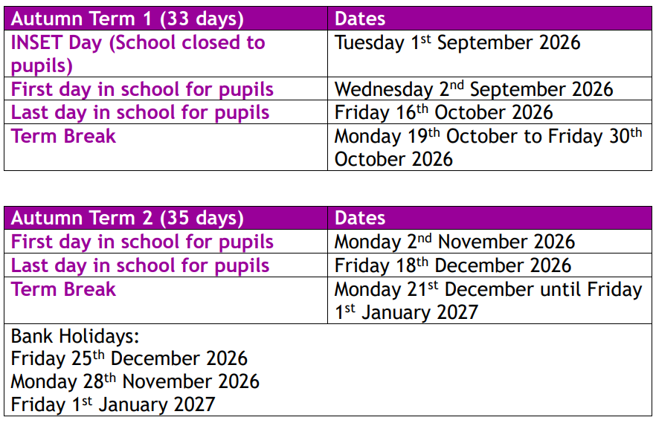

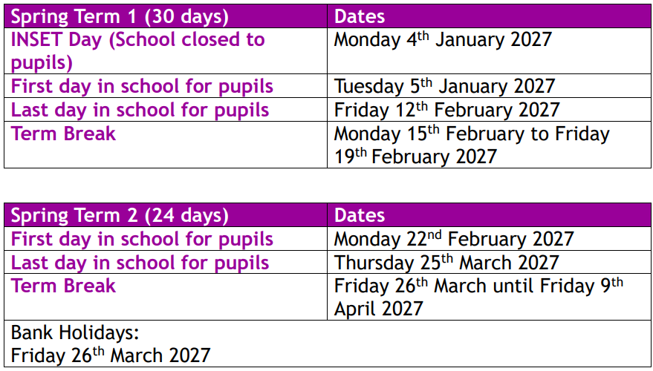

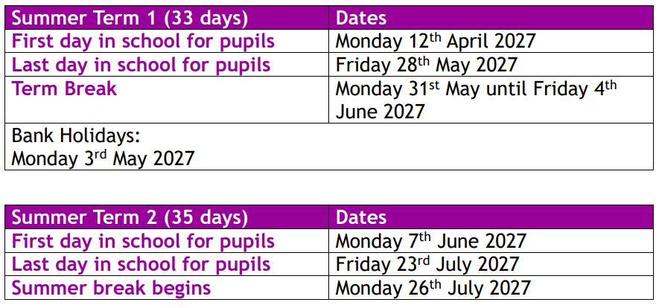

Frequently Asked Questions (FAQs)
What does my child need to bring each day?
Your child will need to bring their book bag and a water bottle every day. Then, depending on the weather they will need a coat, hat, scarf, gloves, sunhat.

Where will my child put their belongings?
Each classroom has an adjoining cloakroom. Each cloakroom has one peg for each child to hang their belongings. Water bottles are stored in the classroom so that they are always available.

What do I do if my child is too ill to come to school?
We know that all children are ill from time-to-time. If our child is unable to come to school due to being ill, please call the school office on (10522) 522633 from 8:30am. Alternatively, you can send an email to enquiries@lincolncarlton.anthemtrust.uk to make us aware. You must ring on every day that your child is ill, otherwise the office team will ring you. If you child has diarrhoea or vomiting, they must remain off school until 48 hours after the last bout.

Does my child need spare clothes in school?
Yes please! All children have accidents from time to time and may need a change of clothes. Please send these in a plastic bag so that they can fit easily onto your child’s peg.

What do I do if I need to speak to my child’s class teacher?
The morning drop-off is very busy and not always an ideal time to talk. If you have a question, or a worry, you can get in contact with your child’s class teacher using their email address (in the handbook). Alternatively, there is always a member of the senior leadership team on the gate who you can talk to and pass any messages on.

What do I do if I have a safeguarding concern?
You need to contact the school immediately if you have a safeguarding concern. You can email the office at enquiries@lincolncarlton.anthemtrust.uk or call (01522) 522633. Alternatively you can email our Designated Safeguarding Lead – Natalie Goodacre – directly at ngoodacre@lincolncarlton.anthemtrust.uk

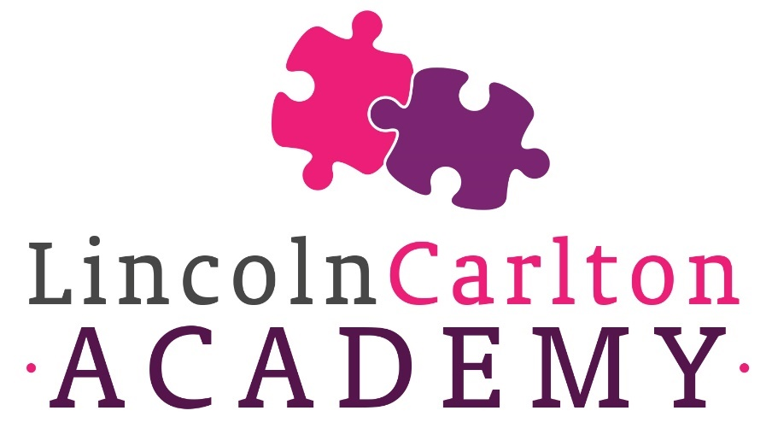

Lincoln Carlton Academy
Carlton Boulevard
Lincoln
LN2 4AG

01522 522633
enquiries@lincolncarlton.anthemtrust.uk



