
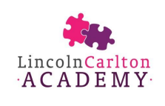

Welcome to Year 1

Meet the Staff


Miss Rouse is the class teacher in Hawthorn class every day of the week.

Mrs Wood is the class teacher in Birch on Mondays, Tuesdays and Wednesday. Mrs ‘Curly’ Clark is the class teacher in Birch on Thursdays and Fridays.

Mrs Lynn is a teaching assistant and she works in Year 1.
All teachers are entitled to spend 10% of their timetable away from the class to plan and prepare lessons. This is known as PPA. In Year 1, this will happen on a Wednesday morning.
Miss Rouse is a newly qualified teacher so she will spend an additional morning out of the classroom each Tuesday.



Miss Smith will teach in Hawthorn on a Tuesday and Wednesday morning.

Mrs Crabtree will teach Birch Class on a Wednesday morning.

Transition from Reception

The end of Reception marks the end of your child’s journey through the Early Years Foundation Stage (EYFS) Curriculum - which they started from birth - and what a journey it has been!

Year 1 is where children start the National Curriculum.

The National Curriculum is divided into four key stages:
Key Stage One – Year 1 and Year 2
Key Stage Two – Years 3, 4, 5 and 6
Key Stage Three – Years 7, 8, and 9 (secondary school)
Key Stage Four – Years 10 and 11 (secondary school)

Getting the transition into Key Stage One and Year 1 right is a key priority for the Year 1 team. The play-based approach adopted in EYFS continues into the first big term of Year 1 to ensure that children don’t feel a big jump in terms of expectations. They will still get to learn through play and access all the areas of learning they are used to from EYFS.

From January, a slow process of transition to whole class learning begins. This means that the children will begin to spend more and more time working with an adult on a task before then moving off the do a task independently at tables. Our teachers are very skilled at this and most children don’t even notice it happening! If you do find that your child is finding this transition tricky, please do speak to your class teacher.

Events

Meet the Teacher
On Tuesday 15th September 2026 at 3pm, come and meet your child’s new class teacher and see the classroom where your child will be learning.

Parent’s Evening
All parents are invited into school for Parent’s Evening on:
Tuesday 10th November or Thursday 19th November 2026
and
Tuesday 13th March or Thursday 22nd March 2027

Christmas Production
The children in Year 1 will take part in a Christmas Production just prior to the Christmas holidays (Weds 9th and Fri 11th Dec). They will take in the role of narrators and the choir whilst their Reception friends act and dance.

Carol Singing on the Green – Thursday 17th December 2026
All Welcome!

EYFS and Year 1 Disco – Thursday 11th February 2027 – 4:30pm – 5:30pm

Thursday 25th February 2027 – SHARE – 3pm – Come to your child’s classroom and find out what they have been learning.

World Book Day – Thursday 4th March 2027 – Dress as your favourite book character or wear your PJs!

Sports Day – Tuesday 15th June 2027 – 1:30pm on the field

End of Year celebration – Thursday 1st July 2027

The Phonics Screening Check
This is a statutory assessment for children in Year 1 in England, designed to assess how well children are progressing with their phonics skills—a key part of learning to read.

📅 When Does It Happen?
Usually in June during the summer term of Year 1.

📋 What Does It Involve?
- Your child will read 40 words (some real, some made-up "pseudo-words") to their teacher.
- Pseudo-words (e.g., "blon", "strom") test decoding skills without relying on memory of known words. At LCA we call them alien words
- The test is done 1-on-1 in a relaxed setting.

🎯 What Is Being Tested?
The focus is on phonics knowledge, particularly:
- Recognising letter-sound correspondences.
- Blending sounds

Results of the screening check are published in your child’s end of year report in July.

The Year 1 Curriculum
Throughout Year 1, the children will cover all aspects of the National Curriculum. This is how the different subject areas are covered:

- Reading (including phonics) – 1 hour per day
- Writing – 1 hour per day
- Maths – 1 hour per day
- Personal, Social, Health and Emotional Education – 1 hour per week
- Science – 1 hour per week
- Computing – 1 hour per week
- Physical Education – 2 hours per week
- Religious Education – 1 hour per week
- Music – 1 hour per week
- Art and Design – 1 hour per week (alternate half terms)
- Design and Technology - 1 hour per week (alternate half terms)
- History – 1 hour per week (alternate half terms)
- Geography - 1 hour per week (alternate half terms)

At the beginning of every new half term, you will receive a detailed overview of everything your child will learn in each of the subjects.

Physical Education (PE)
In Year 1, children start to come to school dressed in their PE kit, rather than getting changed at school. This ensures that they have the maximum amount of time available for exercise and sport! All children in England are entitled to take part in 2 hours of PE every week. PE will always be in the afternoon sessions. Each term, PE days will change and this is so that children can benefit from expert sports coaches who rotate around classrooms throughout the year. We will always let you know your child’s PE days before the end of the previous half term.

Book bags and Backpacks
Every child in Year 1 needs to bring a book bag to school every day. These can be purchased from Uniform Direct for £7.00. Your child does not need to bring a backpack to school as well as we just don’t have space in cloakrooms for these. If you wish to send your child with some spare, emergency clothes then these can be placed in their PE from EYFS to save you buying something new. There is limited room in cloakrooms so please do not purchase backpacks.

Reading
Reading is incredibly important at Key Stage 1 (ages 5–7), and parents play a vital role in helping their children develop strong reading habits. Here's why reading matters at this stage and how parents can support it:

💡 Why Reading Matters in Key Stage 1

Builds Strong Foundations
Children learn to decode words (phonics), build vocabulary, and develop comprehension skills.
These early skills set the stage for all future learning.
Supports Emotional and Social Development
Reading stories helps children understand emotions, relationships, and the world around them.
Books can teach empathy, problem-solving, and self-awareness.
Boosts Confidence and Communication
Children who read regularly tend to develop stronger speaking and listening skills.
They feel more confident expressing their thoughts and ideas.
Encourages Imagination and Creativity
Stories transport children to different places and times, sparking curiosity and creativity.

Improves Academic Success
Strong reading skills benefit all areas of learning: maths, science, history, and beyond.

👨‍👩‍👧‍👦 How Parents Can Help

Read Daily
Even 10–15 minutes a day makes a big difference. Make it part of the bedtime routine.

Talk About the Story
Ask questions like “What do you think will happen next?” or “Why did the character feel that way?”

Be a Reading Role Model
Let your child see you reading books, newspapers, or even recipes. It shows that reading is valuable.

Visit Libraries or Bookshops
Exploring books together can be fun and inspiring. Let your child choose books that interest them.

Celebrate Progress
Praise your child’s efforts, not just their achievements. Confidence grows with encouragement.

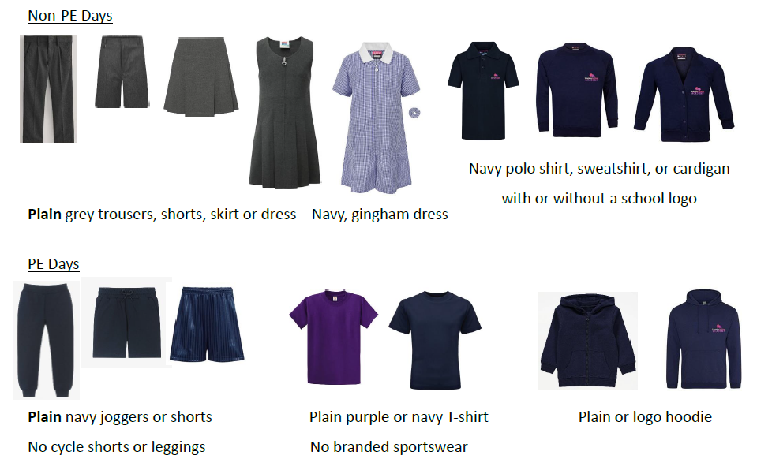
Uniform Policy

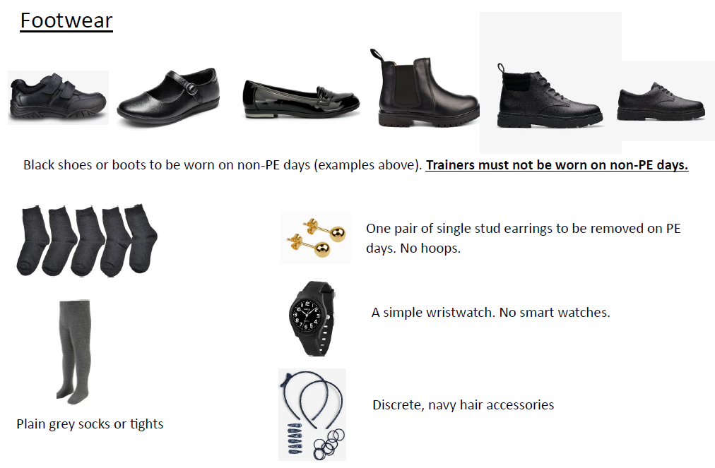

Attendance
Please read our Attendance and Punctuality Policy here Anthem Schools Trust - Policies (anthemtrust.uk).

The government guideline for school attendance is 96.1%.

As a school we expect excellent attendance and as a result work to support families to ensure their child/children achieve an attendance in line with the government guideline of 96.1% or above. We understand that there will be occasions that your child/children are unable to attend school and therefore ask if your child is absent that you contact the school office every day of absence on 01522 522633 or via email before 8:30am, notifying them of the reason for absence. If school has not heard from you by 9:15am then we will start to call the contact numbers from your contact list that you have provided to get an explanation for their absence. If we have not heard from you by the close of register in the afternoon, then we may make a safe and wellbeing home visit to ascertain the whereabouts of your child.
A coding system is used in the registers and any unexplained absence is noted and followed up on.
Every week, our Attendance Team meets to review the attendance of every child in school. If a child’s attendance falls below 96% an initial letter is sent to notify you that your child’s attendance has fallen below the government guideline, and that school will be monitoring their attendance until it improves.
If your child’s attendance continues to decline a further letter will be sent updated, you on the school’s continued concerns around your child’s attendance.
Should your child’s attendance remain at a level below 96% then the school will send you a letter inviting you to attend an Attendance Support Meeting to discuss any issues you are experiencing and offer appropriate support. Should your child’s/children’s
attendance continue to decline and fall below 90% a Fixed Penalty Notice may be issued as the Local Authority place a legal requirement on parents to ensure their child/children receive an adequate education and when attending for 90% or below of the school year your child/children are considered to be ‘persistently absent’, which will have a detrimental impact on their attainment and development.

Lateness
It is important for parents to understand that lateness is classified as an absence. The codes on your child’s attendance record are as follows L - Late (before registers close after 30 mins) and U - Late (after registers close). U is classed as an unauthorised absence for the entire morning session. Your child will be marked as unauthorised if they arrive 30 minutes after the register closes. Registers close at 9:00am in Reception. Should your child arrive after the register is taken at 9.00am they will be marked as late, which will affect their attendance level. Should your child be ‘persistently late’ letters will be sent home notifying you of their attendance level and asking you to attend a meeting with the Attendance Team to discuss any factors that make it difficult for you to get your child/children to school on time and any strategies or solutions we can put in place to see their attendance improve.

Fixed Penalty Notice
Section 7 of the Education Act 1996 outlines that the parent of every child of compulsory school age has a duty to ensure that their child/children receive an efficient fulltime education suitable to their age, ability and any special educational needs he or she may have.

Keeping in Touch
At our school, we believe that children do best when school and families work together. This policy explains how we will keep you informed, listen to your views, and make communication clear and easy.

Talking to your class teacher
It is important that you always have a line of communication directly to your child’s class teacher. This isn’t always easy on the gate in the morning as teachers are welcoming children into the classroom. For this reason, we provide teacher email addresses so that you can contact them directly. Most teachers are in school by 8am and don’t leave until 5pm so they will make contact with you at these points. We encourage you to send messages within these hours as teachers will not respond out-of-hours.

Miss Rouse lrouse@lincolncarlton.anthemtrust.uk
Mrs Wood rwood@lincolncarlton.anthemtrust.uk
Mrs ‘Curly’ Clark rcclark@lincolncarlton.anthemtrust.uk

How We Communicate with you

Talking to You in Person
Talking to parents and carers face-to-face is vital for building relationships between home and school. Early in the school year, you will be invited to a whole class ‘Meet the Teacher’ event where you will meet your child’s class teacher in person.

There are always members of the Senior Leadership Team on the school gates at the beginning and end of the school day and they are more than happy for you to ask questions or to pass messages to your child’s class teacher.

We know that parents and carers often want to speak to their child’s class teacher at the beginning of the school day, however this is difficult for teachers who are working in classrooms without another adult. If you have an urgent message to pass to your child’s class teacher, please speak to a member of the Senior Leadership Team on the gate and they can pass this on for you. Your child’s class teacher will be more than happy to speak to you at a mutually convenient time and this can be arranged by emailing them directly (email addresses can be found in parent handbooks and the school website).

Parent Consultation meetings are planned twice a year – once in November and once in April. This is an opportunity for you to book an appointment to speak to your child’s class teacher in person to talk about their progress and next steps.

Children who are on the Special Educational Needs register will have additional opportunities to meet their child’s teacher throughout the year and class teachers will arrange this.

Emails
Emails are used to share most of the information you will need. Please note that on occasion, emails may go in your junk mail, so please check this regularly. Emails are a two-way form of communication and our enquiries inbox in monitored from 8:30am until 4pm Monday to Friday.

What will we share via email?
- The Daily Digest – sent out at 4pm every day. The Daily Digest will give you all the information you need relating to day-to-day notices, PE days, upcoming workshops, educational visits, assemblies, parent events and fundraisers.
- Curriculum overviews on a half termly basis
- Information about Special Educational Needs reviews
- School reports in the penultimate week of the academic year
- Information about ordering hot meals
- Invitations to special assemblies

School Website
Our school website address is www.lincolncarlton.anthemtrust.uk. Much of the information sent by email can also be found here. There is a large section called curriculum where you will find everything you need to know about what your child will be learning. We will also repeat important notices about school events and fundraisers.

Phone Calls
Phone calls are used to communicate urgent issues but most importantly if your child is unwell during the school day. Please make sure the emergency contact details we have for you are always up-to-date.

Phone calls are also used where a safeguarding concern has been highlighted and we need to speak urgently to parents or carers.

When You Contact Us
- We aim to acknowledge receipt of messages within 24 hours during the school week.
- If we need more time to look into something, we will let you know.
- All communication will be polite, respectful, and professional.
- We ask that parents communicate with staff in the same way.

Emergencies and Urgent Updates
If we need to contact you in an emergency during the school day, we will always make contact via telephone in the first instance. This may be followed up with an email if we are unable to make contact. Please make sure your contact details are always up-to-date.
If we need to send an urgent update to parents and carers linked to this like cancelled clubs, late returns from visits etc. this will be done by email and using the MCAS app.
If you need to make contact with school about an urgent matter between the hours of 8:30am and 4:00pm, please call 01522 522633 and speak to the school office. Although emails are monitored throughout the day, telephoning will always get the quickest response.

If you have a genuine emergency outside of these hours, please contact Mrs Amy Melhuish (Headteacher) on (01522) 457986.

Specific Questions or Concerns

In some cases, you may not feel that the best person to talk to is your child’s class teacher. Here is a list of queries you may have and who to get in touch with.

Safeguarding

If you have a safeguarding concern, please contact:

Mrs Goodacre – Designated Safeguarding Lead

ngoodacre@lincolncarlton.anthemtrust.uk

or

Mrs Melhuish – Deputy Designated Safeguarding Lead

amelhuish@lincolncarlton.anthemtrust.uk

or

Mrs Wright – Deputy Designated Safeguarding Lead

swright@lincolncarlton.anthemtrust.uk

Family Support

Mrs Goodacre – Family Support Worker

ngoodacre@lincolncarlton.anthemtrust.uk

Mrs Goodacre is our Family Support Worker and can offer a offer a listening ear, a cup of coffee (or tea) and support to anyone who needs help with a problem at home.

Pastoral Support

Mrs Goodacre – Family Support Worker

ngoodacre@lincolncarlton.anthemtrust.uk

Sometimes, children can require some extra help in school for many different reasons. If this is connected to a pastoral need (rather than a learning need), please contact Mrs Goodacre.

Curriculum and Assessment

Mrs Sara Wright – Curriculum Lead

swright@lincolncarlton.anthemtrust.uk

If you have any questions about what your child is learning or how they are being taught, please get in touch with Mrs Wright. If you have a very specific subject curriculum question, then please get in touch with the subject leader:

Art and Design – Mrs Evans

cevens@lincolncarlton.athemtrust.uk

Computing – Miss Wroe

nwroe@lincolncarlton.anthemtrust.uk

Design and Technology – Miss Gadsby

Mgadsby-robinson@lincolncarlton.athemtrust.uk

English – Reading – Mrs Christopher

mchristopher@lincolncarlton.anthemtrust.uk

English – Writing – Mrs Wright

swright@lincolncarlton.anthemtrust.uk

Geography – Mrs Ball

aball@lincolncarlton.anthemtrust.uk

History – Mrs Gallivan

Sgallivan@lincolncarlton.anthemtrust.uk

Maths – Miss Cropper

kcropper@lincolncarlton.anthemtrust.uk

Music – Mrs Wood or Mrs Adams

rwood@lincolncarlton.anthemtrust.uk

hadams@lincolncarlton.anthemtrust.uk

Physical Education – Mrs Walker/Mrs Wright

rwalker@lincolncarlton.anthemtrust.uk

Religious Education – Mrs ‘Curly’ Clark

rcclark@lincolncarlton.anthemtrust.uk

Science – Miss Martin

kmartin@lincolncarlton.anthemtrust.uk

Spanish – Miss Michalke

vmichalke@lincolncarlton.anthemtrust.uk

If you have a question or concern about a specific teacher or senior leader, these should be directed to Mrs Melhuish.

Pupil Premium

If you are ensure whether your child is eligible for the Pupil Premium Grant, please contact the school office. If you have a query related to our Pupil Premium Strategy, please get in touch with Mrs Wright.

swright@lincolncarlton.anthemtrust.uk

The Pupil Premium Strategy can be found on our school website:

Lincoln Carlton Academy - Pupil Premium

Special Educational Needs

Mrs Clark

rclark@lincolncarlton.anthemtrust.uk

Mrs Clark is our Special Educational Needs coordinator. If you have concerns, about your child’s learning, please get in touch with your class teacher in the first instance. Mrs Clark can then support you and the class teacher in deciding the next steps for your child.

Behaviour in School

Mrs Clark leads on behaviour and will be happy to talk to you. If you have serious concerns about behaviour in school, these should be directed to Mrs Malam.

Attendance

All queries regarding attendance letters and fixed term penalty notices should be directed to Mrs Melhuish amelhuish@lincolncarlton.anthemtrust.uk#

Personal Development

Child’s Voice – School Council, Timi Champions – Mrs Wright

swright@lincolncarlton.anthemtrust.uk

Pupil Job Roles – Mrs Melhuish

amelhuish@lincolncarlton.anthemtrust.uk

PSHE Curriculum – Miss Ridd

cridd@lincolncarlton.anthemtrust.uk

Enrichment Opportunities – Mrs Wright

swright@lincolncarlton.anthemtrust.uk

After School Clubs – School Office

enquiries@lincolncarlton.anthemtrust.uk

Assemblies – Mrs Melhuish

amelhuish@lincolncarlton.anthemtrust.uk

Term Dates 2026-2027

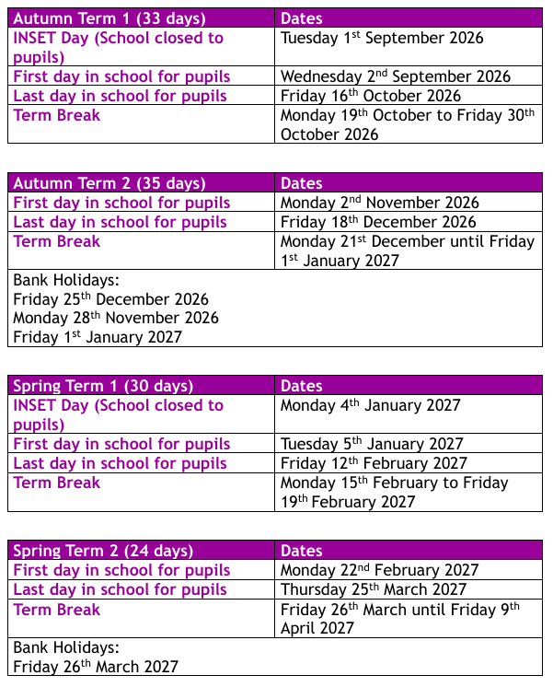

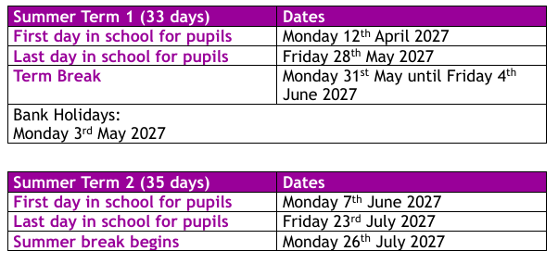

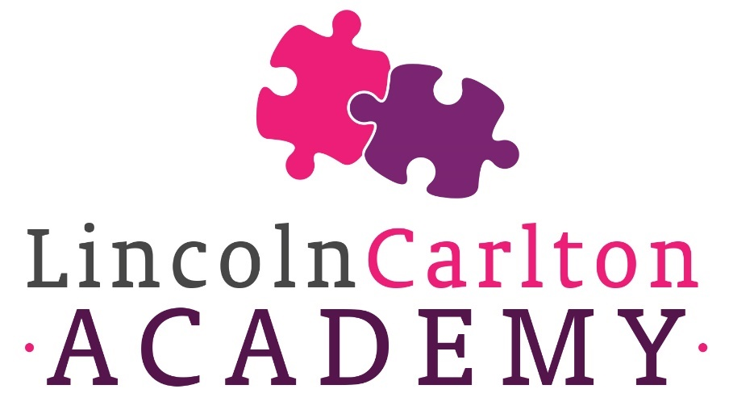

Lincoln Carlton Academy
Carlton Boulevard
Lincoln
LN2 4AG

01522 522633
enquiries@lincolncarlton.anthemtrust.uk



